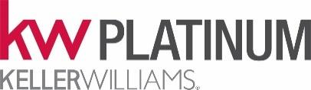

October 9, 2025 -Listing Services
The National Association of REALTORS® Clear Cooperation Policy requires brokers to submit a property listing to the MLS within one business day of public marketing. This policy aims to ensure fair and transparent real estate markets by requiring broad exposure for properties. It has been updated to included options like “office exclusive” and “delayed marketing” listings where sellers can give informed consent to limit marketing for a specified period.
September 30, 2025, was the implementation Deadline.
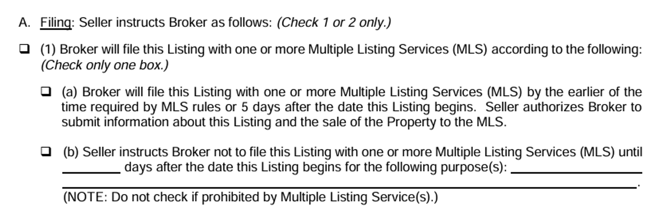
Sellers may choose how they want it marketed and if there is a delay then a SIGNED DISCLOSURE IS REQUIRED. The form is HAR 300 which has been in existence since 2013 but had been revised in 2025. The TXR Listing Agreement allows:
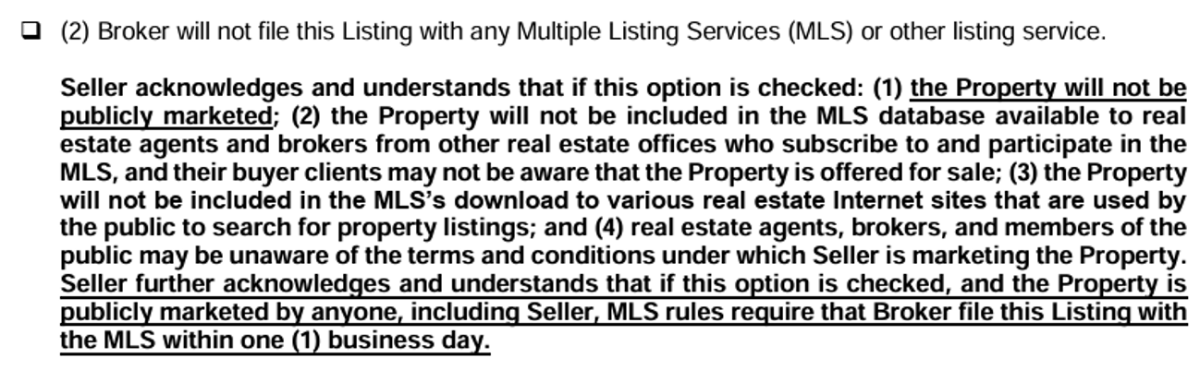
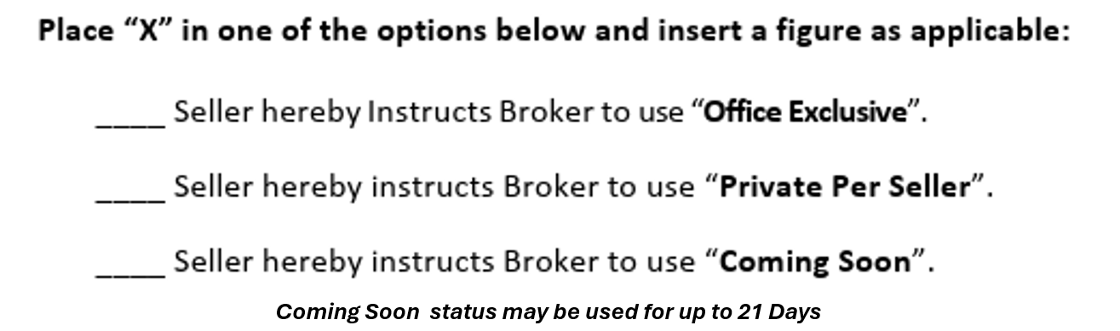
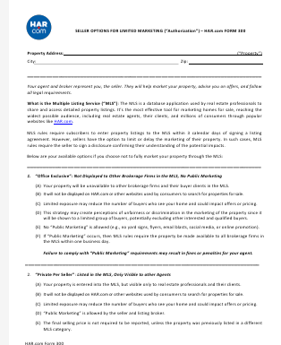
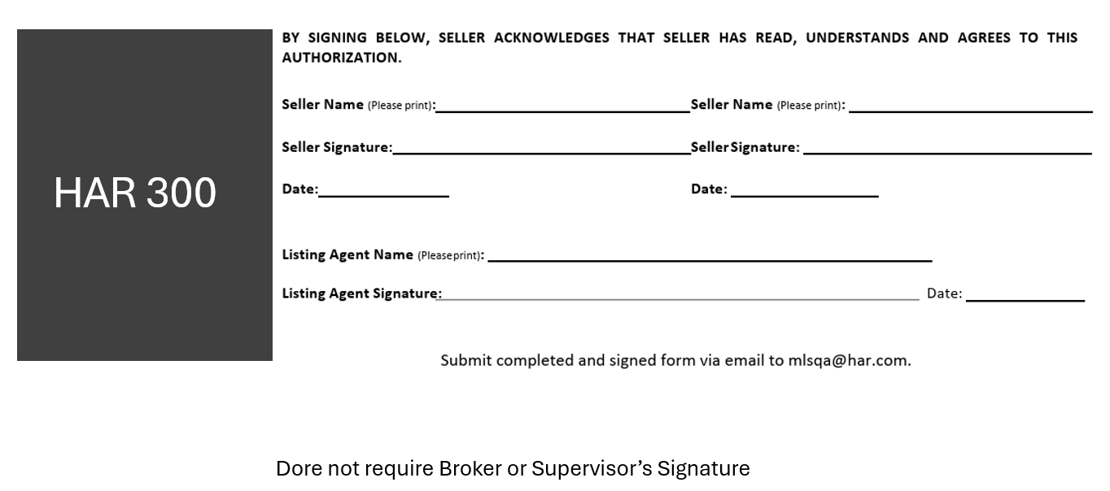
Any questions, contact Ann M. Walker, Broker/Emeritus at 281-381-6066

